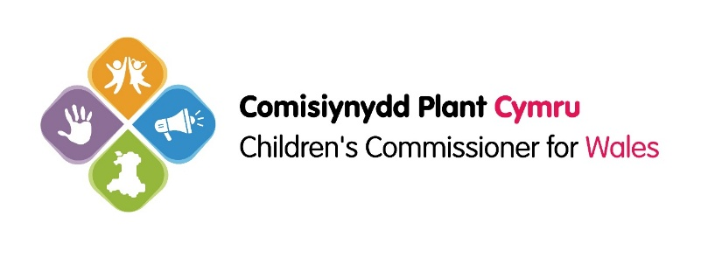

CHILDREN’S COMMISSIONER FOR WALES

Job Description – Advice & Evidence Officer

1. Post Details

Job Title: Advice & Evidence Officer

Main Location: Llewellyn House Harbourside Business Park, Harbourside Rd, Port Talbot SA13 1SB
Pay Band: HEO
Reports to: Head of Advice and Assistance

2. Main purpose objective and context of the role (in summary)
- The main purpose of this role is to support the Children’s Commissioner for Wales achieve positive change for children and young people in Wales and mainstream the principles of the United Nations Convention on the Rights of the Child (UNCRC) into everyday practice.
- You will work within the Advice and Assistance team to provide advice and assistance to individual children, young people, adults and other professionals in accordance with the Children’s Commissioner for Wales’ powers under the Care Standards Act 2000, the Children’s Commissioner for Wales Act 2001 and the Children’s Commissioner for Wales Regulations 2001
- You will lead on analysing the issues and themes emerging from the casework delivered by the Advice and Assistance service to identify trends and patterns, and produce evidence to inform the policy influencing work of the wider organisation.
- You will participate in and project manage cross-functional project groups within the office as appropriate.

3. Main duties and responsibilities
- Support and contribute to the monitoring, analysis and reporting of individual investigation and advice work to gather evidence of the impact of the Advice and Assistance service, in accordance with the office Impact Measurement framework.
- Monitor, analyse and report on trends and patterns of cases brought to the office to identify systemic issues affecting children’s rights and welfare that could require action by the Children's Commissioner for Wales team and bring them to the attention of the Head of Advice and Assistance
- Produce high quality evidence reports, including qualitative and quantitative data, as directed by the Head of Advice and Assistance
- Respond to requests for case-work analysis on specific policy or thematic issues from the wider Management Team.
- To work as a member of the Advice and Assistance function, providing advice and support to children and young people, adults and professionals in accordance with the Children’s Commissioner for Wales’ powers under the Care Standards Act 2000, the Children’s Commissioner for Wales Act 2001 and the Children’s Commissioner for Wales Regulations 2001.

- Contribute to the continued development and operation of a solution-focused advice and assistance service provided for children and young people in Wales,

- Listen, advise, assist and advocate for individual children promoting and safeguarding their rights and welfare.

- Plan and carry out, or participate in, investigations and reviews of breaches of children’s rights in public bodies in Wales and in the preparation and conduct of examinations and service reviews held in accordance with the legal powers of the Commissioner.

- Maintain accurate records of all investigation and advice work on the Advice and Assistance case management system.
- Foster sound working relationships and be an independent, respected, critical friend with all agencies in the statutory and voluntary sectors whose work is relevant to the functions of the Commissioner working to resolve children’s rights and welfare problems in an informal manner if appropriate.
- Represent the Children's Commissioner for Wales at workshops, conferences and seminars an attend, as an observer, key working groups of the Welsh Government and voluntary organisations.
- Promote and embed your expert knowledge of children’s services and safeguarding issues into the work of the office.
- Support the creation of an inclusive and supportive work place culture by providing assistance and occasional cover for duties to colleagues across all functions as necessary.
- Uphold the values of our Team including its commitment to championing the rights of children, supporting the participation work of the office by listening and involving children in key aspects of your work.
- Undertake any other duties within the remit of the grade as deemed necessary by the Management Team or any of its members.

Person Specification for Advice & Evidence Officer at the Children’s Commissioner for Wales
1. Attainments/Qualification
Essential  - A degree or professional level qualification from either education, law, social services, health, play, youth work, youth justice or equivalent experience;  - Evidence of recent and ongoing professional development and learning | Desirable  - A relevant postgraduate qualification | How tested  - Application/ Interview
2. Skills
Essential  - Excellent interpersonal skills with the ability to deal calmly and effectively with multiple pressures and develop successful working relationships internal and external to the organisation;  - Highly literate with excellent communication skills both written and oral;  - Highly competent ITC skills;  - Accurate research and analytical skills, familiarity with both quantitative and qualitative data, and ability to interpret and present complex information in a simple and compelling way  - Good time management and organisational skills; | Desirable  - Project management skills would be an advantage in this role  - The ability to communicate with ease in Welsh with members of the public and external stakeholders, or the aptitude to improve existing Welsh language skills quickly, with encouragement and support; | How tested  - Application/ Interview
3. Knowledge and Experience
Essential  - Previous experience of advising, assisting and advocating on behalf of others ;  - Proven knowledge and experience of child protection and safeguarding and working across organisations to achieve safe outcomes for children and young people;  - Broad experience and evidence of working in partnership with other organisations at all levels to influence and deliver positive outcomes and change for children and young people  - Demonstrates strategic and political awareness and understanding of local and national government strategy and policy agendas with regards to the UNCRC and the rights and welfare of children and young people; | Desirable  - Previous experience of managing a caseload;  - Previous experience of developing evidence-based reports and briefings | How tested  - Application/ Interview
4. Personal Qualities
Essential  - Demonstrates a telephone manner that is re assuring and professional to all callers and especially to those who may be distressed;  - Able to demonstrate an understanding of the values of our office and the human rights agenda;  - Understands the importance of following process and compliance with regulation whilst being outcome focussed and finding innovative solutions to problems;  - Self-motivated and proactive independent practitioner;  - Takes a flexible approach to work and duties with a readiness to respond to changing requirements and urgent requests;  - Committed to representing the views of children and young people and meeting the needs of children and young people in all that we do;  - Displays enthusiasm to be an effective ambassador for children’s rights | Desirable | How tested  - Application/ Interview
5. Circumstances / Special demands of post
Essential  - Ability to undertake occasional travel throughout Wales | Desirable | How tested  - Application/ Interview

