**Young People’s Advisory Panel Members**

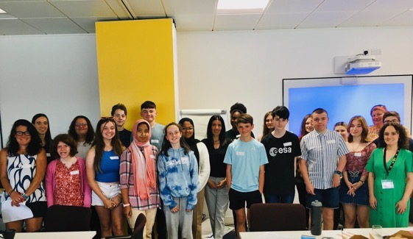

**What do they do?**

* Provide **advice and support** to the Children’s Commissioner, about the way they work with and represent children and young people in Wales.
* **Raise awareness** **of children’s rights** and promote the work of the Children’s Commissioner.
* Work with the Commissioner and team to **review the work plan** each year and provide her with **new ideas and feedback**.
* Work with the Commissioner and team to **review and improve** how the advisory group is working.

**Interested?**

Young People’s Advisory Panel Members must...

* Live in Wales
* Be between 11 and 17 years old (when you start)

And should have:

* Good communication skills so that you can take part in discussions and share your views
* Team working skills
* Experience of sharing views confidently with others
* An interest in children’s rights
* Knowledge or experience of the range of issues young people in Wales face

**Please note:** This year, to make sure we’re giving as many young people as possible the opportunity to take part in panels like ours, we will make sure half of the panel will be made up of young people who have not been a member of a national panel before.

Members must also be:

* Motivated and keen to contribute new ideas
* Respectful and kind to others
* Committed to attending meetings (unless there are unavoidable circumstances that prevent them)
* Committed to remain a panel member for up to 2 years

**What will you get?**

* A great experience in a friendly and supportive team
* Opportunity to make a difference to children and young people in Wales
* Experience which can help you progress towards your personal goals
* Training and support
* Expenses covered to attend meetings and events
* Extra opportunities to take part in our work e.g. events and projects

**When and where do they meet?**

|  |  |  |  |
| --- | --- | --- | --- |
| **Training**  **29th January 2024**  **OR**  **31st January 2024**  Online | **13th February**  **(NORTH WALES)**  **15th February**  **(SOUTH WALES)**  Venues TBC | **17th April**  6pm – 7pm  Online | **19th June**  6pm – 7pm  Online |
| **31st July**  Joint Meeting with Adult Panel  4pm – 6pm  Online | **12th September**  6pm – 7pm  Online | **29th October**  **(NORTH WALES)**  **31st October**  **(SOUTH WALES)**  Venues TBC | **9th December**  6pm – 7pm  Online |

These are the planned **meeting dates for 2024**. We ask that you attend the training and the meetings in February, July and October (highlighted yellow). The other meetings are optional online meetings.

**How to apply?**

Please apply at [www.childcomwales.org.uk/about-us/recruitment/](http://www.childcomwales.org.uk/about-us/recruitment/). You can choose to do an application form, a video or online form.

Closing date: ***18th December 2023***

We will get in touch about your application in **January 2024.**

**For more information please contact:**

Jordan Doherty – Participation Officer   
01792 765600  
[jordan.doherty@childcomwales.org.uk](mailto:jordan.doherty@childcomwales.org.uk)