Participation: How? What? Why?
A guide for professionals

What does it mean?
According to young people, Participation means “it is my right to be involved in making decisions, planning and reviewing an action that might affect me. Having a voice, having a choice”.
Why?
In Wales we have committed to supporting children and young people to access their rights under the United Nations Convention on the Rights of the Child (UNCRC 1989) which outlines 42 Articles or rights children and young people have (see here for full list) Article 12 underpins this and outlines the right to participate as outlined above.
In Wales there is a duty on Welsh Ministers to have due regard to children’s rights in everything that they do, and an important part of the Commissioner’s job is to hold them to account on this. Their decisions should ensure that children’s rights also trickle down to everyday experiences, by applying laws and guidance in a way that gives effect to these rights.
One way that children’s rights will reach experiences in education settings in Wales is through the new curriculum. This is underpinned by learning about rights, and the law that brings it into effect also requires the head teacher and governing body to promote knowledge and understanding of the UNCRC, and of the UNCRPD, to their staff. They can then make sure that that knowledge is applied in how they teach, and in setting school policies and procedures. One way to support a rights based approach to setting school culture and policies is through positive experiences of participation in decision making.
In practice we know participation makes our services even better, here is a short clip to explain why.
https://youtu.be/BCSXGqlVjdM

How?
There are a number of models that can be helpful in thinking about how to involve children and young people in decision making. Many people may be aware of Hart’s ladder of participation (Hart, 1992) which identifies eight levels of children’s participation in projects. It was designed to encourage people working with children to think about the nature and purpose of children’s participation in projects and Hart points out the first three rungs on the ladder are not participation.

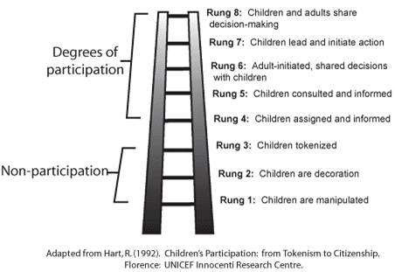

Treseder’s (1997) alternative model shows degrees of involvement in a circular layout, this non-hierarchical model recognizes that in some services involvement will never be youth led e.g. prisons, schools, hospitals.

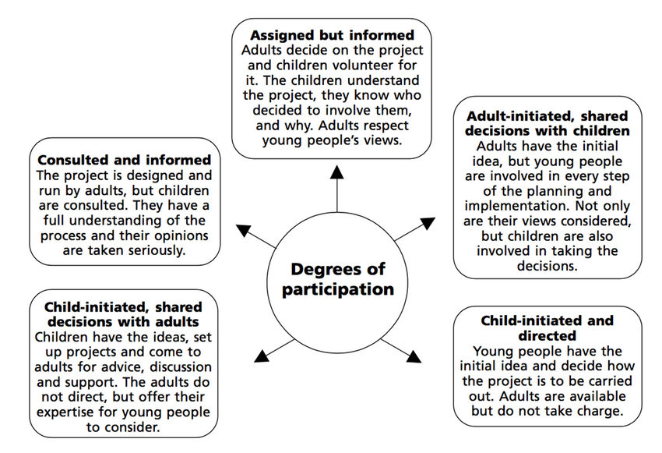

Lastly, The Lundy model of participation (2007) was developed as a simpler model to aid practitioners to meaningfully and effectively implement a child’s right to participate by focusing attention on the distinct but interrelated elements of Article 12. Space; Voice; influence and audience – see image here
In Wales there are National Participation Standards that can help you think through how you can support meaningful participation.
For some examples of good practice around school councils see our report.
Next steps – using our Top tips for school councils, can you work with pupils to identify things needed to move participation forward in your school?
In the next week….
In the next term….
In the next school year
We welcome hearing about any of your work via twitter @childcomwales

https://gov.wales/sites/default/files/inline-documents/2019-03/3_Participation_En%20%281%29.pdf#:~:text=Having%20a%20Voice%2C%20Having%20a%20Choice.%20One%20of,UNCRC%20All%20children%20and%20young%20people%20have%20rights.

