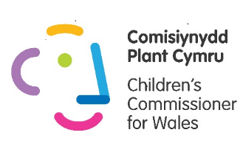
Information about the Role
Young People’s Advisory Panel Members must be between 11 and 18 years old and live in Wales.
When and where do they meet?
The Panel meets 3 times a year for a whole day or 2/3 hours if virtual/online.
The first meeting takes place in February half term 2021, this is a regional meeting (if we are able to meet in person) so this will be held in a venue in both North Wales – February 17th 2021 (Colwyn Bay) and South wales – February 15th (Cardiff) and you can attend the closest one to you.
The second meeting is held in the last two weeks of summer term and is a Natioanl meeting this will be held in Mid Wales on July 7th and is an opportunity for all panel members both adults and young people to come together.
The third meeting takes place on Saturday 9th October 2021 and will be held in separate regional venues for North and South Wales representatives.
There will also be an online training session before your first meeting – Tuesday 9th February 6-7.30 p.m. 2021
There are more optional opportunities to be involved in the work of the Team throughout the two year position on the panel.

What do they do when they meet?
- Provide advice and support to Sally Holland, the Children’s Commissioner, about the way her organisation works with and represents children and young people in Wales.
- Raise awareness of children’s rights and promote the work of the Children’s Commissioner for Wales.
- Work with Sally and her team to review the work plan each year and provide her with new ideas and feedback.
- Work with Sally and her team to review and improve how the advisory group is working including recruiting and supporting new members.
They need to have :
- Good communication skills so that they can take part in discussions and share their views
- Team working skills, an ability to work with other people to achieve a shared goal
- Some previous experience of representing others e.g. school council, youth forum
- Experience of sharing their views confidently with others
- An interest in children’s rights
- Knowledge or experience of the range of issues young people in Wales face
They are:
- Motivated and keen to contribute new ideas
- Respectful and kind to others
- Committed to attending 3 meetings each year for two years (unless there are unavoidable circumstances that prevent them)

