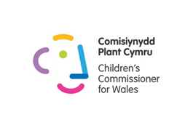
Guidance for training

Context:
The Children’s Commissioner for Wales Office has worked with teachers in the EAS consortia area to pilot training sessions that they can cascade to staff around the United Nations Convention on the Rights of the Child (UNCRC) and the role of Children’s Commissioner for Wales.

Why deliver this training?
A Children’s Rights Approach to education will safeguard the long term needs of children and young people and will develop healthy and confident individuals who can learn and thrive. Implementing this approach also provides meaningful opportunities for children and young people to participate as ethical, informed citizens in their communities.

Who is aimed at?
This training is designed for primary and secondary teachers to peer lead in staff twilight/training sessions and is based in a presentation with links to resources and videos, this includes practical activities, examples from other schools and time to reflect on link to the four purposes and Areas of Learning.

How long does it take?
This has been designed as two 1½ hour sessions, which can be delivered separately or put together to be one 3 hour session.

What do you need?
Access to powerpoint and audio, time to download linked resources and to prepare any resources. Based on feedback from our pilot it was suggested that senior management endorse this training so it is supported as a whole school approach.

See our Top Tips and resources to help embed UNCRC across the school

See our document which links UNCRC to the new curriculum

