Ambassadors Spring Mission 2019
Guidance for teachers

Guidance for Teachers

Background
In 2015, children and young people told us through the Children’s Commissioner for Wales’ Beth Nesa survey that bullying was a top concern for them and more needed to be done to tackle it. We began work on ‘Sam’s Story’ – a project on tackling bullying – which produced a report, lesson plans, anti-bullying displays and an exhibition at the Senedd. The project was met with a positive reaction, however children and young people felt that we could do more, particularly in regards to cyberbullying.
We’ve been gathering data from children and young people to find out about their online lives, how they feel about cyberbullying and what they think should be done to tackle it. Children and young people from all over Wales took part in workshops and focus groups. We also spoke with teachers and youth workers to learn more about challenges they face when dealing with instances of cyberbullying and what could be improved in order to help them to tackle the issues in schools and youth work settings.
A number of children’s rights in the UNCRC are threatened or denied in the many descriptions of bullying that we received as part of ‘Sam’s Story’. Particularly relevant are:
- Article 2 - No young person should be treated differently because of who they are, where they live or what they believe.
- Article 6 - The right to life and the right to develop.
- Article 8 – The right to an identity.
- Article 19 - The right to be protected from all forms of violence and abuse.
- Article 28 - The right to an education.

Key findings
We have worked with over 400 children and over 150 professionals on this phase of the project. These are their key messages:
- Children and young people are able to identify a wide range of common negative online experiences, including negativity about looks and identity, being frozen out from the ‘in’ groups and threats of violence. They would like to have more opportunities to share their experiences of online bullying and discuss coping strategies in safe, non-judgmental spaces.

- Peer-led strategies and interventions are valued by many children and young people.

- Teachers often lack information about new technology and how it is used by children and young people and many feel overwhelmed by the issue. They often have to deal with the consequences of bullying taking place overnight and after school hours, as well as the impact this has on children’s ability to learn. Some teachers can find parents’ behaviour undermining if they intervene inappropriately online after their children have been bullied, or do not restrict children’s access to apps and games designed for older young people or adults.

- Young people and professionals feel parents are unsure about what to do about online bullying and that they often do not understand their children’s online lives. They can feel disappointed if schools do not take action regarding online bullying.

We have used these key messages to develop this mission for Spring 2019.

Spring Mission 2019
We’d like our Super and Student Ambassadors to set up action groups in their schools or settings, who will raise awareness of cyberbullying.
This should be a group of young people who are willing to get involved, lead some activities and who feel passionate about doing something positive to tackle online bullying.
This mission is based on activities and actions that children and young people, teachers and youth workers tell us help to tackle online bullying.
Young people have told us they want safe spaces to discuss the issues and how to cope, and for cyberbullying to be taken seriously and dealt with.
Young people and their teachers also told us that peer-led (pupils in charge) initiatives were effective in tackling online bullying.

Guidance for teachers
- We’ve created an action pack that includes activities and actions for the group to use in their school or community. There are primary, secondary and accessible versions of the action pack available.
- The aim is for young people to own the action pack. We’d like teachers to enable young people to lead the activities where possible, and support them as appropriate.
- We’d like teachers and workers to support young people to set up their group by:
  - Helping them understand the information
  - Letting them to be involved in delivering activities
  - Listening to their ideas
  - Supporting them to implement changes
- Young people can use the action pack as part of their curriculum. We have linked to curriculum frameworks at the end of this document.
- The accessible action pack has visual symbols (Widgit) and can be used to support a total communication approach with children and young people with additional learning needs.
- You may have a group that already exists e.g. digital leaders who can do this work, or you can set up a new group. You could hold an election, pick names out of a hat or invite any young people who are interested to take part in the group.
- The group will be stronger if it reflects and represents the diversity in your community. Every child or young person who wants to be involved should have the chance to take part.
- The action packs include an evaluation form for the group to complete by Friday 12th April. This will allow the group to tell us what they thought about the mission, what they did and show us the changes they’re making.
- You can also Tweet us during our #RightsHour (every Friday 12pm - 1pm).

How will this resource support work in schools?
- The resource will empower children and young people and give them an active role in making change in their school.
- It can support the development of outcomes of The National Literacy and Numeracy Framework, with links to outcomes in the oracy, reading and writing strands.
- It can support the development of outcomes of the Digital Competence Framework in particular in the citizenship and producing strands.
- The Personal and Social Education Framework through active citizenship, health and emotional well-being and preparing for lifelong learning.
- It can offer an authentic context for developing skills related to the Skills Challenge Certificate of the Welsh Baccalaureate at Key Stage 4.
- The Estyn Common Inspection Framework 2017 through the Wellbeing and attitudes to learning and Care, support and guidance inspection areas.
- The Four Purposes of the new curriculum for Wales, in particular:
Ambitious, capable learners who: | - Can explain the ideas and concepts they are learning about [1.5]  - Use digital technologies creatively to communicate, find and analyse information [1.8]
Enterprising, creative contributors who: | - Think creatively to reframe and solve problems [2.2]  - Lead and play different roles in teams effectively and responsibly [2.5]  - Express ideas and emotions through different media [2.6]  - Give of their energy and skills so that other people will benefit [2.7]
Ethical, informed citizens who: | - Engage with contemporary issues based upon their knowledge and values [3.2]  - Understand and exercise their human and democratic responsibilities and rights [3.3]  - Understand and consider the impact of their actions when make choices and acting [3.4]
Healthy, confident individuals who: | - Are building their mental and emotional well-being by developing confidence, resilience and empathy [4.2]  - Have the confidence to participate in performance [4.7]  - Face and overcome challenge [4.9]
We would like to thank Ysgol Cedewain, Powys for their work in linking this resource to the Four Purposes. The Four Purposes in full can be seen on the next page.

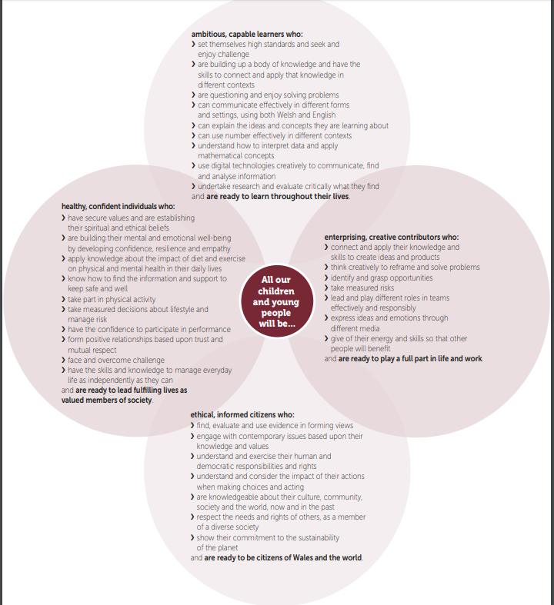

Professor Graham Donaldson CB, Successful Futures: Independent Review of Curriculum and Assessment Arrangements in Wales, February 2015. Available here.

