Information for Applicants

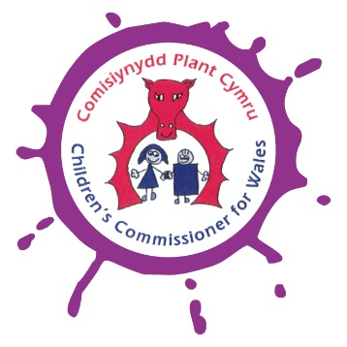
Contents

- Introduction

- Values and vision

- A whole team approach

- Equality and valuing diversity

- Applying for a job at the Children’s Commissioner for Wales

- The interview process

- Benefits and conditions of employment

Introduction
Thank you for expressing an interest in a position within the Office of the Children’s Commissioner for Wales. Our recruitment process aims to attract quality applicants and above all to recruit the right people. This document contains information about the Children’s Commissioner for Wales, the recruitment process and our employment terms and conditions which you may find useful.

Values and Vision
In 2001, the National Assembly for Wales decided Wales needed a children’s champion.
This person would be known as the Children’s Commissioner for Wales and would become the UK’s first children’s champion. They would be selected with help from children and young people and would make sure children and young people learnt about their rights and were kept safe. They would be able to keep what has been described as the ‘best job in Wales’ for seven years.

Sally Holland is the current Commissioner and will be the Children’s Commissioner for Wales until 2022.

Our Vision
We aspire to a Wales where all children and young people have an equal chance to be the best that they can be.

The work of the Children’s Commissioner is guided by the United Nations Convention on the Rights of the Child (UNCRC) and she strives to ensure that it is fully implemented in Wales.

Our Values
Our office has rules and values. These are the things which help us build a team that think the same way about what the Children’s Commissioner for Wales should be doing. These eight values help us make sure every decision we make is made for the right reason. These are our foundations.

Here’s our set of values as an organisation
- Children and young people play a clear and genuine part in informing and helping direct our work.
- We will ensure that children and young people with whom we have contact are kept safe through our policies and practices.
- We aim to combat discrimination in all forms and adhere to equalities legislation in all spheres of our work.
- We give English and Welsh languages equal status in our organisation and external communications and encourage the use of Welsh as an everyday language in our office.
- We will adhere to the One Welsh Public Service Values as a context for the values and principles of our work.

Our Principles for Delivery:
And here are our principles for the delivery of our work:

- We need to deliver the best value we can with our public money.
- All activities will be linked clearly to the organisation’s strategic plan.
- We will be as transparent as possible, internally and externally, regarding how we have made decisions about priorities and methods of delivery.
- We will maintain clear, logical and strong governance structures and quality assurance mechanisms.
- Wherever possible, the organisation will measure the impact of its activities.
- We will develop and maintain logical and efficient systems management for storing, retrieving, analysing, monitoring and reporting data.
- We will work alongside other organisations where this will be of benefit to further the rights of children in Wales, but we will retain the ability to independently scrutinise public bodies.
- We will treat all people who contact our office with respect and courtesy at all times. We will maintain a clear and accessible complaints policy.
- We aim to be an employer that values and enables employees’ contributions and gives them an opportunity to develop their skills.

In our current three year Plan for all Children and Young People, we share the Commissioner’s ambitions for children and young people in Wales. You can find more documents about our work and take a look at our plan here: www.childcomwales.org.uk/ourwork
A whole team approach
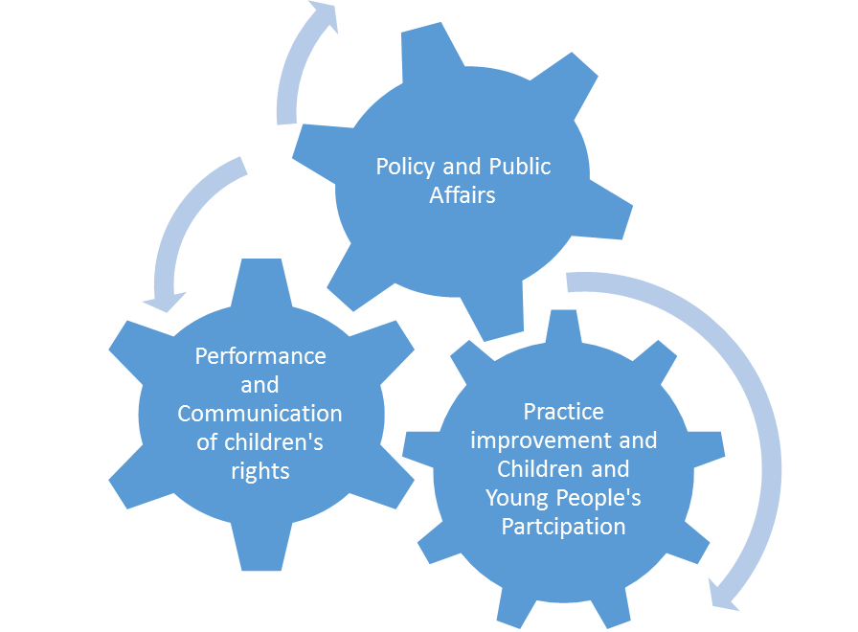

The Office of the Children’s Commissioner for Wales consists of three interrelated functions that work together in a whole team approach.

The organisation delivers a work programme that is completely interdependent. Officers will take expert roles within this according to their specialism but all will be dependent on the other parts of the organisation to deliver their core work programme.

Our policy work, individual case work and participation work all interlink as shown above to achieve our key aims of safeguarding and promoting children’s rights in Wales supported by our Financial and administrative services , Communications team, Executive Assistant and Human Resources Officer. All are equally vital in fulfilling our aims and it would not be possible to fulfil our statutory remit without each of these areas of activity. Relationships between the teams delivering these functions are reciprocal. E.g. Investigation and Advice Officers provide skills and knowledge to Policy and Participation teams, and vice versa. Data from our investigation and advice and participation work should be systematically collated and analysed and used to inform our policy and practice improvement work.

All team members engage in participation work, although Participation Officers lead this work and provide expert advice to colleagues. All team members support the goal of improving policy and practice through their activities, although this work is co-ordinated by the Policy Officers. Individual casework is led by Investigation and Advice Officers but informed and supported by Policy Officers. Participation Officers may also assist in meetings with groups of children who have contacted the office about their situation. Our Finance, administrative, Human Resources and Communications Officers work to underpin and support the work of the organisation, driving performance and the communication and public understanding of our work.

Performance and Communications Team
The Head of Performance and Communications works directly to the Children’s Commissioner for Wales leading on the development and implementation of an external communications strategy aimed at raising the profile of the Commissioner, her role and the work of her office, in addition to establishing a coherent internal governance and performance framework for the organisation. The Head of Performance and Communication will develop and co-ordinate crisis management plans along with implementing and monitoring the organisation’s internal communications strategy, leading on the editing and production of all corporate publications, acting as media spokesperson as requested by the Commissioner and managing the out-of-hours media contact point.

The overall aim of our communications work is to position the Commissioner as the voice of authority on children and young people’s issues in Wales. In addition the team aims to achieve excellent media coverage for the organisation across all aspects of the work of the Children’s Commissioner for Wales, ensuring that key messages are communicated to all relevant stakeholders, and ensuring high-quality publications are produced and disseminated to relevant stakeholders on behalf of the Commissioner.

Other members of this team include our Digital Communications Officer who is responsible for developing and implementing the Children’s Commissioner for Wales’ digital communications strategy, which includes managing the content of the website and the Commissioner’s social media platforms.

Other responsibilities of the Performance and Communication Team include providing expertise in effective and sustainable governance, strategic planning, performance evaluation, and administration and informatics systems. These systems ensure that as a public body we comply with the principles outlined by “The Good Governance Standard for Public Services “ so that our accountability and decision-making functions are rigorous and transparent.
The Head of Performance and Communications has responsibility for the staff members employed to maintain and develop these systems:
Our Administrative Officers provide the full range of support activities to their work colleagues and provide telephone and welcoming reception services to children and young people, visitors to the office other professionals and the general public, including advice on health and safety at work.
Our IT Officer ensures that the work of the organisation is enabled and enhanced by robust information technology resources and systems.

Practice and Participation Team
The Practice and Participation Team consists of 3 full time Investigations and Advice Officers and 4 part time (3 full time equivalent)Participation Officers, line managed by the Head of Practice
Our Investigation and Advice Officers work within the Practice and Participation Team. They are based in our Swansea Office but are responsible for dealing with cases for the whole of Wales. . They act as a source of help and support for children and young people (or those who care for them and about them) who feel they have been or perceive themselves to have been treated in a prejudicial manner that has breached their rights. Children and young people, parents and carers, or other professionals contact the team in a number of different ways, by phone, text, letter or email. A member of the team acting as the duty officer for the day will determine what action needs to be taken on a case-by-case basis.

We will do our best to identify a quick solution to resolve issues at the lowest possible level. We may speak to people over the telephone or we may ask for meetings to help the child or young person have their say. This may involve referral to another organisation, signposting to another organisation or we may become directly involved in a case. We will never give a child or young person another telephone number to call; we will always make the initial contact on their behalf.

The Officers travel all over Wales to meet with children and young people, to listen, support and advocate on their behalf. We have Welsh-speaking Officers and have access to interpreters to enable any child, young person or adult with concerns over a child to communicate with us in their preferred language.

The Head of Practice will investigate breaches of children’s rights in public bodies across Wales and make recommendations for changes to practice that will effect positive systemic change for children and young people in Wales. He is also responsible for conducting reviews of complaints, whistle blowing and arrangements for advocacy services within regulated services in Wales.

Our Participation Officers support all other Officers in their work to inform children and young people, and adults who work with them, about the work of the Children’s Commissioner for Wales and the UN Convention on the Rights of the Child. Participation Officers also support all other Officers to gather the views of children and young people, listen to what children and young people have to say and involve children and young people directly in the work of the office

The office of the Children‘s Commissioner for Wales works with ambassadors in schools across Wales. Super Ambassadors are children who are elected by their peers; their job is to raise awareness about the Children’s Commissioner for Wales and children’s rights in their own school communities.

In addition to this, Officers meet and engage with groups of children and young people to let them know about the Commissioner and listen to their experiences. What they tell us informs our work focus and policy responses with a view to affecting change for all Wales’ children.

Policy and Public Affairs Team
The Policy team consists of the Head of Policy and Public Affairs and four Policy Officers. The team seeks to ensure that children’s rights are delivered to all children in Wales in a number of ways including responding to proposed legislation in both the UK Parliament and National Assembly for Wales and responding to consultations on new or revised guidance and regulations produced by the Welsh Government.

The team also undertakes monitoring of the recommendations previously made by the Commissioner, including the Clywch inquiry, Unofficial Exclusions, Bordering on Concern and Full of Care. By monitoring the recommendations, the team seeks to ensure that organisations respond to the concerns the Commissioner has identified and help to ensure positive changes for children and young people.
The team has undertaken a number of service evaluations looking at the implementation of policy and how such policies affect children and young people’s lives and rights. Examples of such evaluations have included work on the provision of wheelchairs to children and young people, Child and Adolescent Mental Health Services and play for disabled children.

The team also monitors the implementation of the United Nations Convention on the Rights of the Child (UNCRC) in Wales and the implementation of the Welsh Government’s action plan on the 2008 Concluding Observations. With colleagues across the other Commissioners’ Offices in the UK we monitor the overall implementation of the UNCRC in the UK and report on progress to the United Nations Committee on the Rights of the Child.

Finance Team
This team consists of the Head of Finance and a Finance Officer.
Our Finance Team works to ensure that all business activity is conducted with the highest regard to financial regularity ensuring that the Commissioner complies with statutory and best practice accounting requirements.
Management Team
The Management Team consists of the Children’s Commissioner for Wales, the Head of Communications and Performance, the Head of Practice, the Head of Policy and Public Affairs, the Head of Finance and the Head of Human Resources, supported in their meetings by the Executive Assistant.
All participants in the Management Team report directly to the Children’s Commissioner for Wales and work together to ensure that performance management and accountability arrangements are in place across the office, develop organisational strategy and annual work plans to deliver the strategic goals and vision of the office and discuss and make operational decisions to ensure the delivery of the office work plan.
The Executive Assistant provides comprehensive support directly to the Children’s Commissioner for Wales in the delivery of her role and function.
Equality and Valuing Diversity
The Children’s Commissioner for Wales’s supports, implements and promotes the principles and values of equality and diversity in its work. Our commitment to equality and diversity means that we welcome and celebrate working in a multi-cultural, multi-faith, diverse society and believe that no one should be unfairly treated.

Being a good employer is essential to fulfill our purpose. Every employee has a responsibility in fulfilling our commitment to equality and diversity. This is crucial to our responsibilities as an employer and for our work with children and young people.

We also believe that any employee who feels isolated, excluded, or thinks they have been treated unfairly, should have support and redress through the organisation’s policies and procedures for dignity at work, grievance and unsatisfactory conduct.

Equality and Diversity Monitoring Form
We work proactively to identify and remove barriers in our employment opportunities and in our work with children and young people. We do this in part through monitoring, equality impact assessment, reporting and action planning. As part of our overall commitment to equality for a diverse workforce, we aim to create a culture within which all staff have the right to be treated with dignity and respect and a culture that ensures that no one receives less favourable treatment on the grounds of race, ethnic origin, religion or belief, age, gender, sexual orientation, disability, or marital status.

Diversity monitoring helps us achieve these goals by helping us understand the make- up of our workforce in respect of these characteristics.

We therefore ask and encourage all applicants and our staff to complete our equality and diversity monitoring form which can be found on our website. The information provided will help us to:
- develop and improve our practices;
- build and maintain equality of opportunity and diversity across our organisation; and
- demonstrate our commitment to promoting equality and valuing and respecting diversity in all that we do as an employer and as a champion for children.

We would like to reassure you that this form will be handled separately from your application form when it is received by the Office. It will not be used to assess your suitability for employment.

Applying for a job at the Children’s Commissioner for Wales
As part of our Recruitment and Selection Policy and Equality Scheme we want to ensure that every applicant is treated fairly. The only information that is used to decide whether or not to short-list an applicant is the information provided in your application form. Your application form is therefore very important and this section is designed to help you to complete it. If you already work for us we still require the same range of information in relation to the job you are applying for.

The job description and person specification
Every post advertised by the Children’s Commissioner for Wales is supported by a job description and person specification. The job description outlines the main duties of the post, and the person specification describes the knowledge, experience and skills required for the position. If, after reading the job description, you are still interested in the job, then consider whether you have the relevant skills and experience, as detailed in the person specification. If you do, consider how to demonstrate this.
In your application form (see the next section) make sure that you give enough detail about how you meet each of the criteria.

Completing the application form
Read through the application form carefully before you write anything to make sure that you are clear about what is being asked. You may find it helpful to do a rough version first – this avoids mistakes and allows you to organise your application properly. Please note that we only accept application forms, not CVs. If your application is not fully completed or is marked ‘see CV’ it will not be considered.

This application form must be completed in black ink or typed please, as it will be photocopied. You can return the form by post to the address stated on the top of the application form or by e mail to:
Amanda.evans@childcomwales.org.uk

Personal details
You must complete this section accurately as the information you provide here helps us to comply with the Asylum and Immigration Act 1996. We are unable to offer employment to someone who does not have the right to live and work in the UK. If you are offered the post, it is conditional on you providing proof of this right through documentation such as a national insurance number, P45 or passport. Our Human Resources Officer will be able to provide further guidance.

Previous employment
When completing this section of the application form it is essential that you include any relevant voluntary, paid or part-time work that you have had. If you have never been in paid employment or have not worked for a long time, you should think carefully about any other relevant experience, not necessarily in a formal work setting, that you may have gained.

Please also make sure that you include details of your current or most recent job, even if you feel that the job is not relevant to your current application. You should explain the main features of your role, including things that you are or were responsible for, but do not go into too much detail. You should, where possible, confirm salary details for your current or most recent job.

You will have the opportunity to expand on the skills and experience that are most relevant to your application later in the form.

You should also provide details of your past employment, starting with the most recent job and accounting for any periods of time not spent in further education or employment.

Qualifications
The person specification sets out any qualifications required for the job, and you should list these in this section. You may also want to include any other qualifications you possess or training courses you have attended that you feel are relevant for the post. If you are offered the post, we will need to view the qualification certificates that you list.

Record of achievements
This section of the application form is very important. Use it to demonstrate how your knowledge, experience and skills match the selection criteria listed in the person specification.
You should show how you possess the knowledge, skills and experience outlined in the person specification by giving specific examples of your main achievements from your own experience.
If necessary you can continue on a maximum of two additional A4 sheets. Each additional page must be numbered and must include your name and the job title of the position you are applying for.

Welsh Language skills
Our Welsh Language Scheme outlines a set of core principles aimed at ensuring the equal treatment of both Welsh and English in the workplace. Our core principles maintain that:

- We will create and promote access to every service we provide through the medium of Welsh and English. These services will include written communication, electronic communication and face to face interaction;
- We will provide an equally high quality of service in Welsh and English; and
- We will increase the public confidence in the provision of both Welsh and English.

In order to achieve these aims we ask all applicants to indicate their skill level in the Welsh language.

Rehabilitation of Offenders Act 1974 (Exceptions Order 1975)
Make sure that you complete this section of the form. As we work with children and young people all posts are exempt from the Rehabilitation of Offenders Act 1974, which means that all convictions, both spent and unspent, must be disclosed. This includes any cautions, reprimands, including being bound over or warnings and also driving offences. This also includes a criminal offence for which you may have been charged but for which a decision is pending.

All posts within the Children’s Commissioner for Wales are subject to an enhanced disclosure check from the Disclosure and Barring Service (DBS). The DBS will check the background of job applicants to make sure that they do not have a history that would make them unsuitable for certain posts.

It is very important to answer questions relating to previous convictions on the application form honestly and carefully. Please take time to consider the information. If you have a criminal record then this will not automatically prevent you being employed. We will take the nature of your offence and its relevance to the job into consideration. A copy of our policy on the disclosure of a criminal background is available on request.
Should you be employed and it is subsequently found that you failed to disclose a conviction or warning it is likely that your employment will be at risk.

References
All appointments require the receipt of two references that are deemed satisfactory by the Children’s Commissioners’ interview panel. All candidates will be asked permission to approach their referees prior to the interview stage.

The Children’s Commissioner for Wales will not make appointments before we have received references, therefore where a candidate has indicated on their application form that they do not give their permission for the Human Resources Officer to approach their referees prior to interview, a member of the interview panel will explain this to the candidate. At this stage of the interview process the panel will seek the candidate’s permission to take up their references.

Your two referees should represent your present or most recent employer and a previous employer. Within this framework, you should give details of the person(s) most able to confirm your suitability for the post for which you are applying. The Children’s Commissioner for Wales reserves the right to contact any other past employers it deems necessary. If you have not worked in paid employment, you may provide the name and address of anyone who knows you well and who will be able to confirm the information you have provided and comment on your suitability for the job.

Internal candidates should give their line manager as a first referee.

Specific questions
In this part of the application form there are three specific questions that provide you with an opportunity to demonstrate in more detail your suitability for the post. You should answer the questions concisely, be aware that some questions may have a word limit, illustrating your responses with concrete examples and with the job description and person specification in mind. You may refer to experience, skills and knowledge gained in your current post, or through paid or unpaid work or study. If appropriate you may also refer to personal experience which has increased your skills or knowledge. Your answers should be well structured and clearly expressed since they form part of the assessment. Anything you mention may be discussed in more depth at interview, should your application progress to that stage.

Declaration
When you have completed the application form read through it carefully, checking for any errors and to make sure you have not missed anything out. Then sign and date it to confirm that the information is correct.

Interview process
If you are short listed you will be advised of the date and time of your interview in writing and you will also be informed of any additional requirements at this time such as presentations.

The Children’s Commissioner for Wales is committed to the meaningful inclusion of children and young people in recruitment and selection processes therefore should you be invited to interview the process will include young people who have received appropriate training and preparation.

If you have any special requirements because of for example a disability, please contact the Human Resources Officer who will be pleased to assist you.

Benefits and terms of employment
The Children’s Commissioner for Wales has a comprehensive set of employment policies, procedures and guidelines that enable us to operate effectively and fairly with our employees. Our policies are generally in excess of the statutory and market requirements, particularly regarding leave and maternity rights. These conditions apply to all staff employed by the Children’s Commissioner for Wales.

Working hours
Full time hours of work are 35 hours per week. Office hours are normally 9.00 am – 5.00 pm although team members are supported to work from remote locations and benefit from flexible working patterns. Team members are encouraged to work in a way that encourages environmental sustainability, a good work life balance and a healthy lifestyle.

Annual Leave
Entitlement is 31 days per year for all full-time posts and at all grades. In addition, there are 8 bank holidays and an additional 1.5 privilege days awarded per year. Part time workers are entitled to a pro rata amount of leave and bank/privilege holidays based on contracted hours.

Pension Scheme
The Children’s Commissioner for Wales is part of the Principal Civil Service Pension Scheme details of which can be found on the following web site:
www.civilservice.gov.uk

Child care vouchers
The Children’s Commissioner for Wales recognises that employees need flexible pre-school and out-of-school childcare of a type and in a location most convenient to them. Childcare vouchers allow employees to choose their own childcare provider and to have their childcare costs reduced. Childcare vouchers help to improve the working lives of staff, helping them to balance work with caring responsibilities. This benefit is operated within a salary sacrifice scheme.

Trade Union membership
The Children’s Commissioner for Wales has entered into a recognition agreement with the Public and Commercial Services Union (PCS)

Employee well-being and sick pay entitlements
We offer a comprehensive Employee Wellbeing Policy and Procedure which includes the provision of an Employee Assistance Service and an occupational sick pay scheme that offers up to six months’ full pay and six months’ half pay, depending on length of service accrued with the Children’s Commissioner for Wales.

