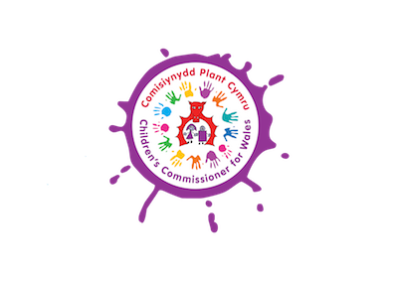
MONITORING FORM
In order to ensure that our Youth Panel is representative of children and young people across Wales we need you to answer the following questions. This information will be kept confidential.
Gender
Male
Female
Other
I'd rather not say

Gender Identity -Trans is an umbrella term for people whose gender identity is different in some way to the gender category they were assigned at birth. Using this definition, do you consider yourself Trans?
Yes
No
I'd rather not say

Welsh Language skills (delete as appropriate)
Fluent Welsh speaker | Yes/ No
Understand and speak some Welsh | Yes/ No
Welsh learner | Yes/ No

Which of the following do you most identify with? Please tick
White - Welsh
White - Scottish
White - English
White - Irish
White - British
White - Gypsy or Irish Traveller
Any other White background
Mixed - White and Black Caribbean
Mixed - White and Black African
Mixed - White and Asian
Any other Mixed background
Indian
Pakistani
Chinese
Bangladeshi
Any other Asian background
African
Caribbean
Any other Black/African/Caribbean background
Arab
Other

Disability
Do you consider yourself to have a disability? Yes / No (delete as appropriate)
If you answered no, please ignore the remaining questions in this section.
If you have answered yes, please tick the categories that apply to you.
Hearing impairment
Visual impairment
Speech impairment
Mobility Impairment
Physical co-ordination difficulties
Reduced Physical capacity
Learning difficulties
Other

Do you have any caring responsibilities? Yes/No (delete as appropriate)

Have you ever been in care (e.g. foster care, residential care or looked after by the local authority)? Yes/No (delete as appropriate)

How did you hear about this opportunity?

